5-2-2021

1)Generate a calendar by getting the year from the user?

Calendar.html

<!DOCTYPE html>

<html lang="en">

<head>

<meta charset="UTF-8">

<title>Calendar</title>

<meta name="viewport" content="width=device-width, initial-scale=1, shrink-to-fit=no">

<!-- Bootstrap CSS -->

<link rel="stylesheet" href="https://stackpath.bootstrapcdn.com/bootstrap/4.1.0/css/bootstrap.min.css"

integrity="sha384-9gVQ4dYFwwWSjIDZnLEWnxCjeSWFphJiwGPXr1jddIhOegiu1FwO5qRGvFXOdJZ4" crossorigin="anonymous">

</head>

<style>

.sun{

background-color: rgba(255, 0, 0, 0.76);

color: white;

}

.restDays{

background-color: rgba(75, 180, 43, 0.767);

color: white;

}

</style>

<body>

<div class="container col-sm-4 col-md-7 col-lg-4 mt-5">

<div class="card">

<h3 class="card-header" id="monthAndYear"></h3>

<table class="table table-bordered table-responsive-sm" id="calendar">

<thead>

<tr>

<th class="sun" style="border-top-left-radius: 15px;">Sun</th>

<th class="restDays">Mon</th>

<th class="restDays">Tue</th>

<th class="restDays">Wed</th>

<th class="restDays">Thu</th>

<th class="restDays">Fri</th>

<th class="restDays" style="border-top-right-radius: 15px;">Sat</th>

</tr>

</thead>

<tbody id="calendar-body">

</tbody>

</table>

<div class="form-inline">

<button class="btn btn-outline-success col-sm-6" style="border-bottom-left-radius: 15px;" id="previous" onclick="previous()">Previous</button>

<button class="btn btn-outline-success col-sm-6" style="border-bottom-right-radius: 15px;" id="next" onclick="next()">Next</button>

</div>

<br/>

<form class="form-inline">

<label class="lead mr-2 ml-2" for="month">Jump To: </label>

<select class="form-control col-sm-4" name="month" id="month" onchange="jump()">

<option value=0>Jan</option>

<option value=1>Feb</option>

<option value=2>Mar</option>

<option value=3>Apr</option>

<option value=4>May</option>

<option value=5>Jun</option>

<option value=6>Jul</option>

<option value=7>Aug</option>

<option value=8>Sep</option>

<option value=9>Oct</option>

<option value=10>Nov</option>

<option value=11>Dec</option>

</select>

<label for="year"></label><select class="form-control col-sm-4" name="year" id="year" onchange="jump()">

<option value=2000>2000</option>

<option value=2001>2001</option>

<option value=2002>2002</option>

<option value=2003>2003</option>

<option value=2004>2004</option>

<option value=2005>2005</option>

<option value=2006>2006</option>

<option value=2007>2007</option>

<option value=2008>2008</option>

<option value=2009>2009</option>

<option value=2010>2010</option>

<option value=2011>2011</option>

<option value=2012>2012</option>

<option value=2013>2013</option>

<option value=2014>2014</option>

<option value=2015>2015</option>

<option value=2016>2016</option>

<option value=2017>2017</option>

<option value=2018>2018</option>

<option value=2019>2019</option>

<option value=2020>2020</option>

<option value=2021>2021</option>

<option value=2022>2022</option>

<option value=2023>2023</option>

<option value=2024>2024</option>

<option value=2025>2025</option>

<option value=2026>2026</option>

<option value=2027>2027</option>

<option value=2028>2028</option>

<option value=2029>2029</option>

<option value=2030>2030</option>

<option value=2031>2031</option>

<option value=2021>2032</option>

<option value=2022>2033</option>

<option value=2023>2034</option>

<option value=2024>2035</option>

<option value=2025>2036</option>

<option value=2026>2037</option>

<option value=2027>2038</option>

<option value=2028>2039</option>

<option value=2029>2040</option>

<option value=2030>2041</option>

<option value=2031>2042</option>

<option value=2021>2043</option>

<option value=2022>2044</option>

<option value=2023>2045</option>

<option value=2024>2046</option>

<option value=2025>2047</option>

<option value=2026>2048</option>

<option value=2027>2049</option>

<option value=2028>2050</option>

</select></form>

</div>

</div>

<script src="cal.js"></script>

<script src="https://code.jquery.com/jquery-3.3.1.slim.min.js"

integrity="sha384-q8i/X+965DzO0rT7abK41JStQIAqVgRVzpbzo5smXKp4YfRvH+8abtTE1Pi6jizo"

crossorigin="anonymous"></script>

<script src="https://cdnjs.cloudflare.com/ajax/libs/popper.js/1.14.0/umd/popper.min.js"

integrity="sha384-cs/chFZiN24E4KMATLdqdvsezGxaGsi4hLGOzlXwp5UZB1LY//20VyM2taTB4QvJ"

crossorigin="anonymous"></script>

<script src="https://stackpath.bootstrapcdn.com/bootstrap/4.1.0/js/bootstrap.min.js"

integrity="sha384-uefMccjFJAIv6A+rW+L4AHf99KvxDjWSu1z9VI8SKNVmz4sk7buKt/6v9KI65qnm"

crossorigin="anonymous"></script>

</body>

</html>

Calendar.js

let today = new Date();

let currentMonth = today.getMonth();

let currentYear = today.getFullYear();

let selectYear = document.getElementById("year");

let selectMonth = document.getElementById("month");

let months = ["January", "February", "March", "April", "May", "June", "July", "August", "September", "October", "November", "December"];

let monthAndYear = document.getElementById("monthAndYear");

showCalendar(currentMonth, currentYear);

function next() {

currentYear = (currentMonth === 11) ? currentYear + 1 : currentYear;

currentMonth = (currentMonth + 1) % 12;

showCalendar(currentMonth, currentYear);

}

function previous() {

currentYear = (currentMonth === 0) ? currentYear - 1 : currentYear;

currentMonth = (currentMonth === 0) ? 11 : currentMonth - 1;

showCalendar(currentMonth, currentYear);

}

function jump() {

currentYear = parseInt(selectYear.value);

currentMonth = parseInt(selectMonth.value);

showCalendar(currentMonth, currentYear);

}

function showCalendar(month, year) {

let firstDay = (new Date(year, month)).getDay();

let daysInMonth = 32 - new Date(year, month, 32).getDate();

let tbl = document.getElementById("calendar-body"); // body of the calendar

tbl.innerHTML = "";

monthAndYear.innerHTML = months[month] + " " + year;

selectYear.value = year;

selectMonth.value = month;

let date = 1;

for (let i = 0; i < 6; i++) {

let row = document.createElement("tr");

for (let j = 0; j < 7; j++) {

if (i === 0 && j < firstDay) {

let cell = document.createElement("td");

let cellText = document.createTextNode("");

cell.appendChild(cellText);

row.appendChild(cell);

}

else if (date > daysInMonth) {

break;

}

else {

let cell = document.createElement("td");

let cellText = document.createTextNode(date);

if (date === today.getDate() && year === today.getFullYear() && month === today.getMonth()) {

cell.classList.add("bg-info");

} // color today's date

cell.appendChild(cellText);

row.appendChild(cell);

date++;

}

}

tbl.appendChild(row); // appending each row into calendar body.

}

}

**Output**

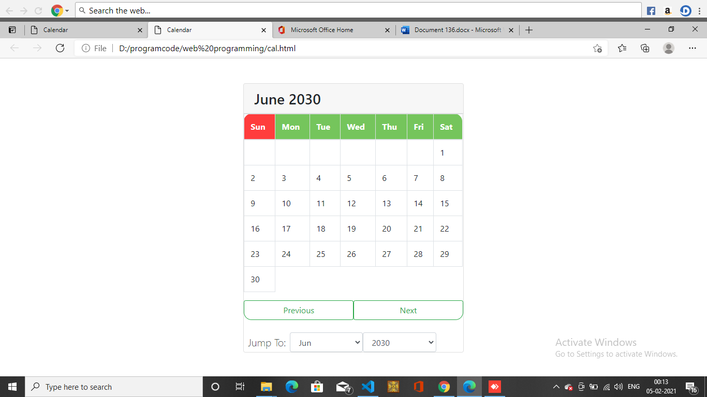

2)create a html page to calculate the total marks of a student by getting . Marks of 5 subjects from the user and then show the total marks to the user?

<!DOCTYPE html>

<html>

<head>

<title>Enter Marks</title>

<script type="text/javascript">

function submit_marks() {

var sub1 = parseInt(document.getElementById('s1').value);

var sub2 = parseInt(document.getElementById('s2').value);

var sub3 = parseInt(document.getElementById('s3').value);

var sub4 = parseInt(document.getElementById('s4').value);

var sub5 = parseInt(document.getElementById('s5').value);

var sub6 = parseInt(document.getElementById('s6').value);

var total = sub1+sub2+sub3+sub4+sub5+sub6;

document.getElementById("demo").innerHTML = "Your Total Marks : "+total;

}

</script>

</head>

<body bgcolor="green">

<center>

<h1>Enter Students Marks</h1>

<input type="text" id="s1" placeholder="Enter English Marks"><br><br>

<input type="text" id="s2" placeholder="Enter Python Marks"><br><br>

<input type="text" id="s3" placeholder="Enter Software Engineering Marks"><br><br>

<input type="text" id="s4" placeholder="Enter Digitaland Fundamentals Marks"><br><br>

<input type="text" id="s5" placeholder="Enter Maths Marks"><br><br>

<input type="text" id="s6" placeholder="Enter CPP Marks"><br><br>

<input type="submit" onclick="submit_marks()">

<div id="demo"></div>

</center>

</body>

</html>

output

